Press Release
For Immediate Release
From Try Lines to Trend Lines: Jockey® South Africa's Limited Edition Campaign Scores Big
Jockey® South Africa, the local arm of the internationally recognised underwear and clothing brand, has like our beloved Springboks also triumphed during the recent rugby world cup but in the retail space with its “Take One for the Team” marketing campaign. The world cup centred concept saw the development of a limited edition product range for men and women that captured the essence and camaraderie of the sport while infusing a distinctive South African flavour into the messaging and concept.
Unfolding after the first week in August and throughout September, the “Take One for the Team” campaign garnered approximately 8 219 views on the dedicated landing page, generated over 16 000 social media leads, and received over 800 competition entries. Successfully rolled out on a limited budget, the campaign not only resonated with rugby enthusiasts across South Africa and exceeded all expectations by reaching over 5 646 052 loyal customers countrywide; but by strategically tapping into the nationwide rugby fever, Jockey South Africa® positioned its brand at the forefront of a global trend.
According to Sharlene David, Brand Manager at Jockey® South Africa, the campaign took inspiration from the nation’s collective hope of securing a back-to-back and fourth title while offering other competing countries’ fans the chance to also express their support for their favourite teams, both on and off the field. “We were thrilled to have received feedback from our international Jockey Head Office team that our South African campaign was one of the most creative and inspiring campaign’s to have been rolled out in comparison to any other region’s 2023 world cup campaigns. In fact, the demand was so high by South African’s to ‘take one for the team’ that we had to manufacture a second run of this limited edition range within the first week of September,” enthused David.
At the heart of the campaign was a cheeky billboard showcasing a line-up of men on a rugby field proudly sporting team-inspired Jockey® trunks, while paying homage to the spirit of the world cup. The catchy phrase "Take One for the Team" served as a call to action, inviting consumers to purchase limited edition trunks or bra tops in their favourite team's flag and country’s colours before 30th September 2023, for a chance to win an exciting world cup screening experience valued at R50,000 for not only themselves but 20 friends as well.
True to Jockey's style, these team-inspired undergarments also provided buyers with world-class comfort and style. The men’s colour-blocked short trunks boast contoured panels, a 2-needle cover seam detail, a striped out gusset, and wide jacquard elastic. Meanwhile, the ladies’ festive bra is wire-free with adjustable straps and removable pads, offering lasting quality with a sustainable blend of 95% cotton and 5% Lycra. All garments in the range have been crafted responsibly in partnership with the Better Cotton Initiative (BCI).
David further shared her enthusiasm regarding the triumphant outcome of the recent ‘Take One for the Team’ campaign, saying, “We are absolutely thrilled with this campaign’s success, which transcended just promoting quality products to our consumers but managed to also strike an emotional chord. We remain committed to delivering campaigns and product innovation that is inspired by our customers’ needs and wants while never straying from our promise of producing quality garments.”
ENDS
Words: 540
Images: Campaign images
Distributed on behalf of: Jockey® South Africa
Date: November 2023

Notes to the editor:
About – 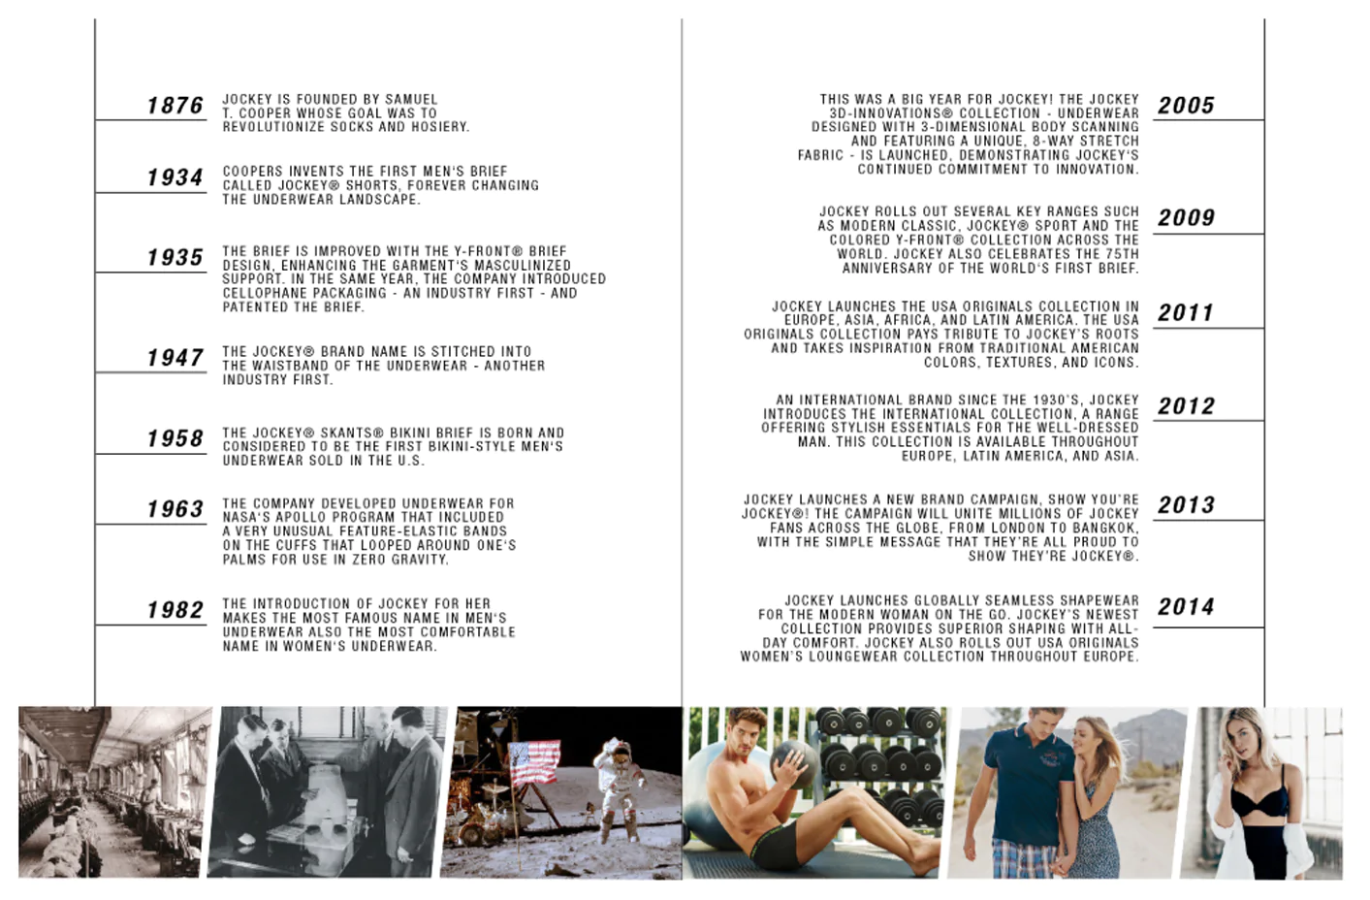

For more information or visuals, please contact Janna Strang on janna@rainmakermarketing.co.za / 082 551 3865 or email Mbali Mpofu on mbali@rainmakermarketing.co.za

